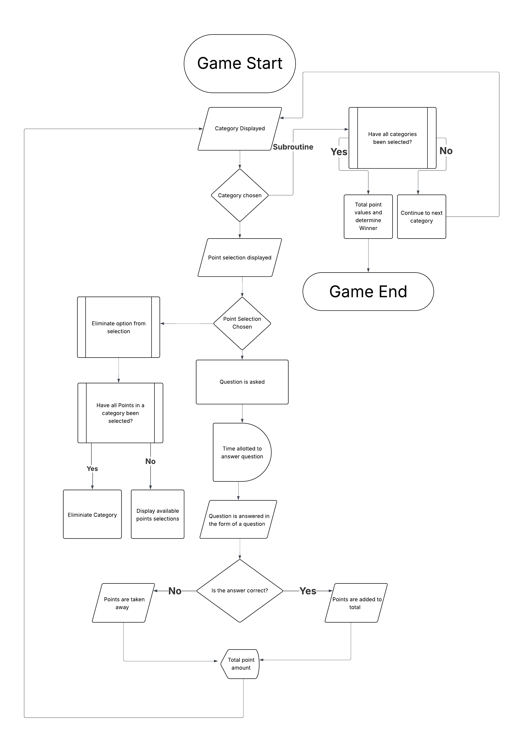
Module 5 – Exercise 1 Flowcharting – Meredyth Black

